**Potential applications of static webcams for visibility observation**

**For definition of Visibility:**

Guide to Instruments and Methods of Observation (WMO-No. 8), Chapter 9,

https://www.weather.gov/media/epz/mesonet/CWOP-WMO8.pdf

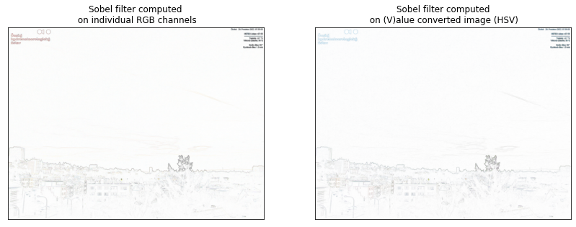

Day

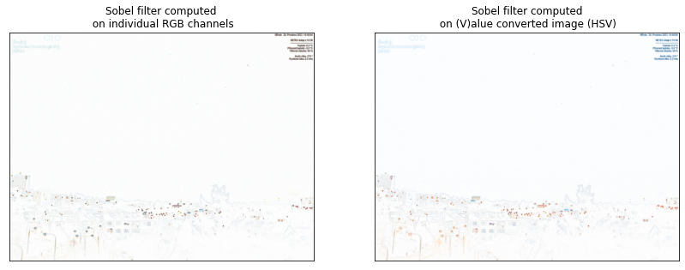

Night

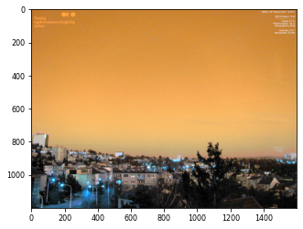

Equalization (img_eq = exposure.equalize_hist(img))

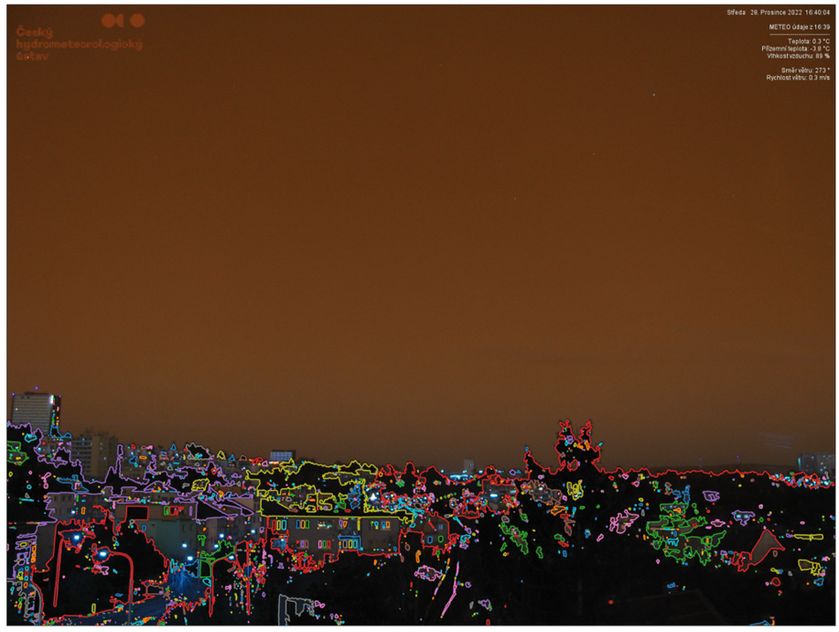

Greyscale -> find contours

<https://scikit-image.org/docs/stable/auto_examples/edges/plot_contours.html#sphx-glr-auto-examples-edges-plot-contours-py>

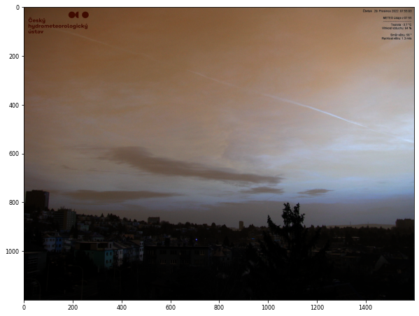

Gamma corrected

**Sobel edge detection**

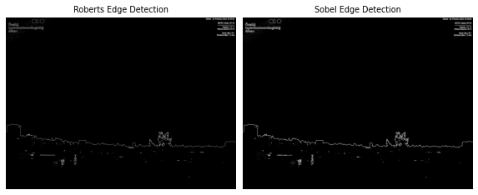

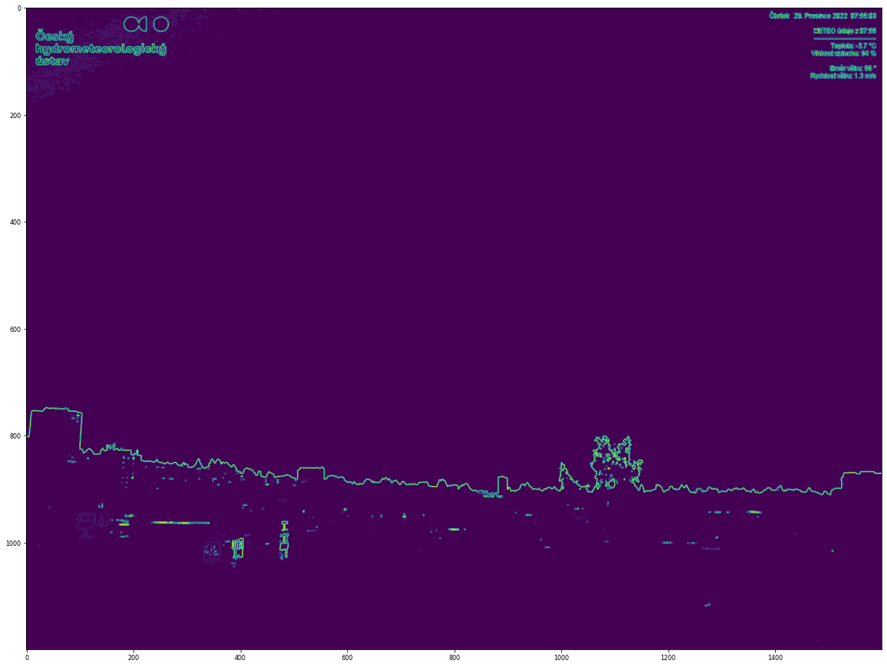

7:55 Sobel

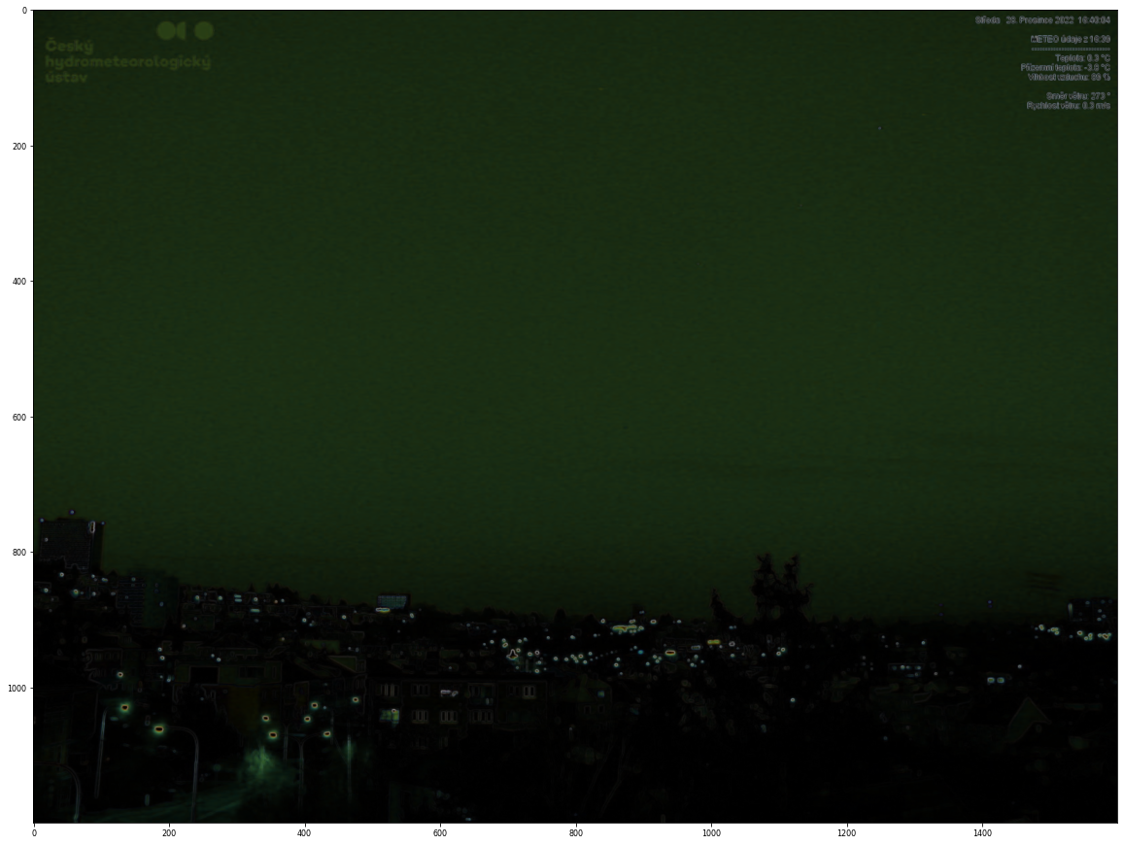

16:40 Without preprocessing – Sobel

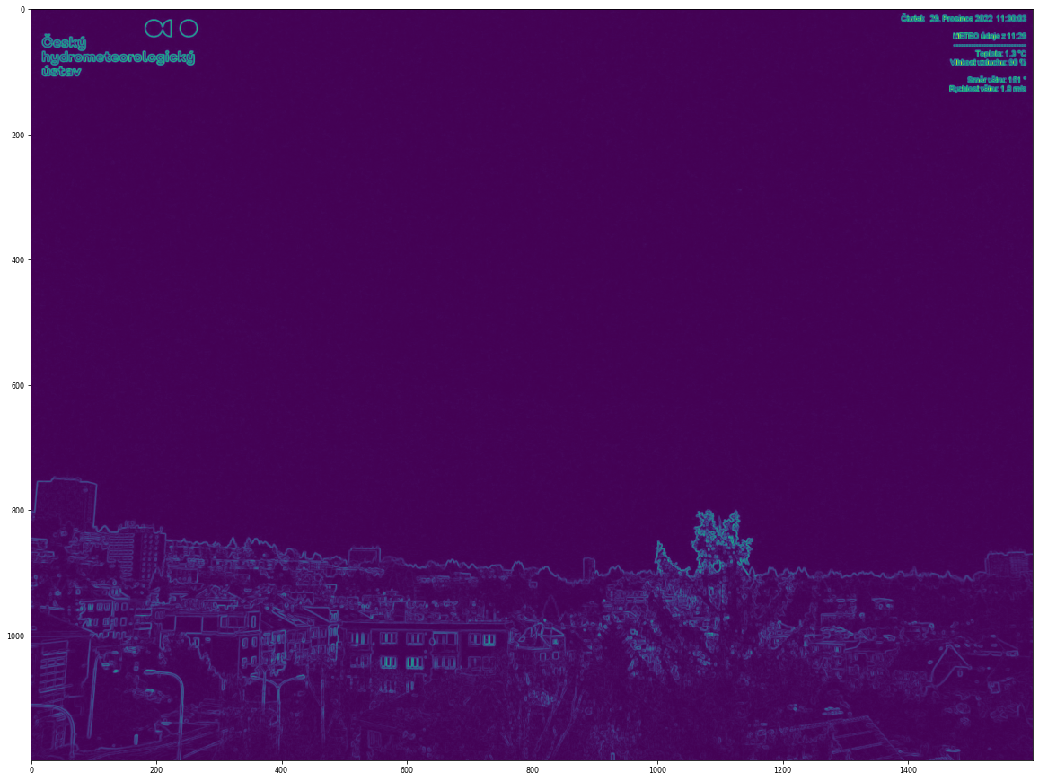

11:40 rgb – greyscale – Sobel

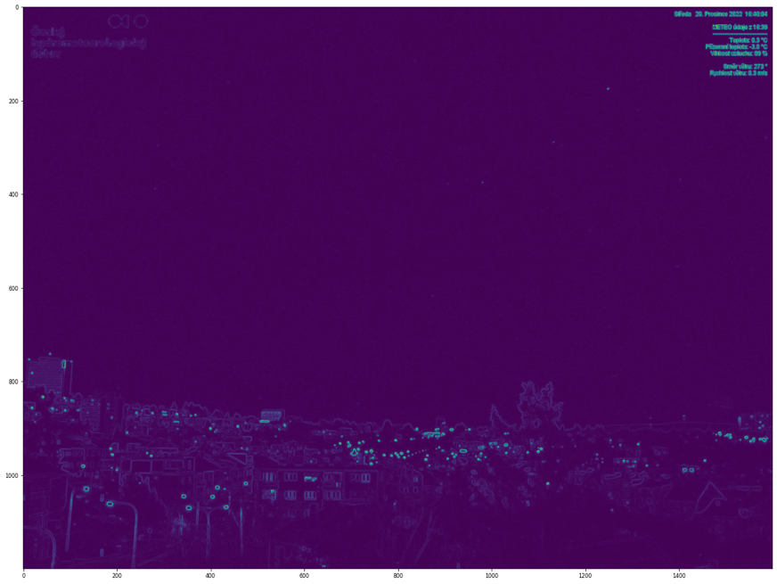

16:40 dark – greyscale – Sobel

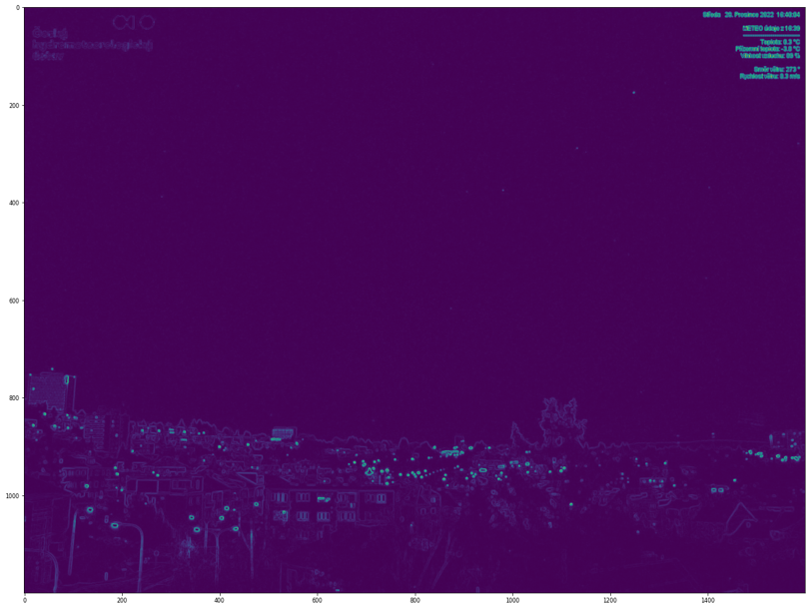

adjust Gamma = 0.7

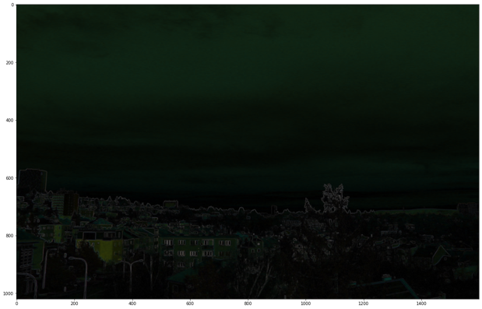

sobel, no grayscale

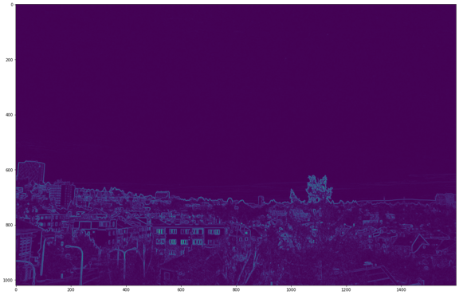

greyscale + sobel

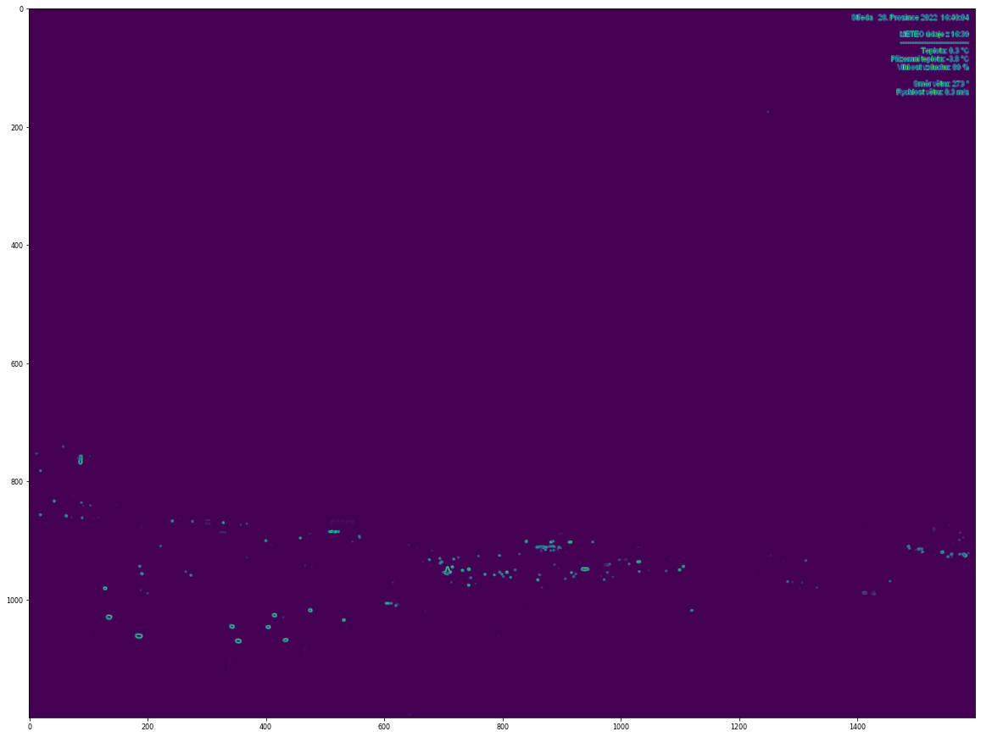

adjust gamma = 5

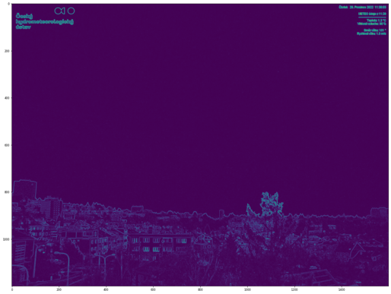

11:40, adj_gamma =1

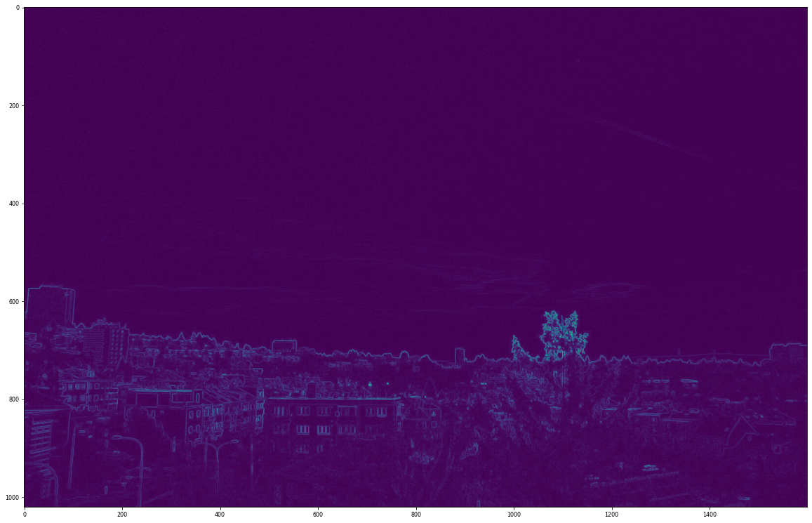

Cropped, log, grey, Roberts (7:55)

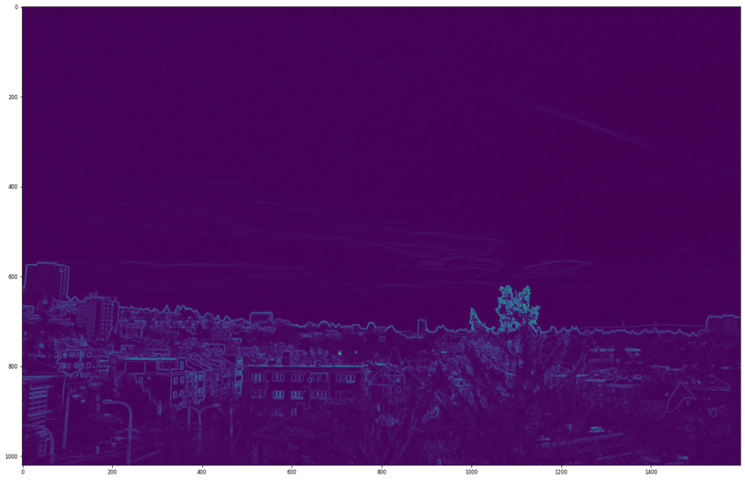

Cropped, log, grey, Sobel (7:55)

**Prewitt filter**

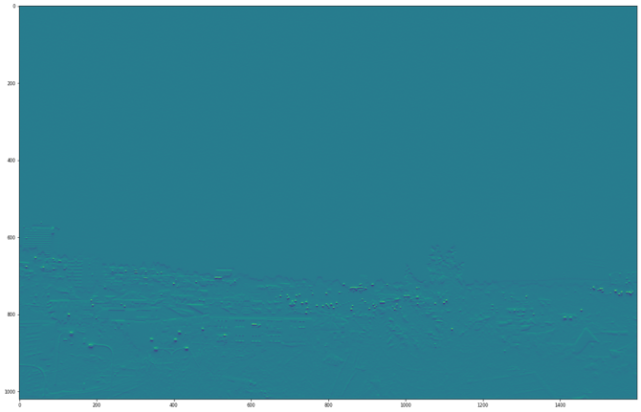

1640 Prewit_h

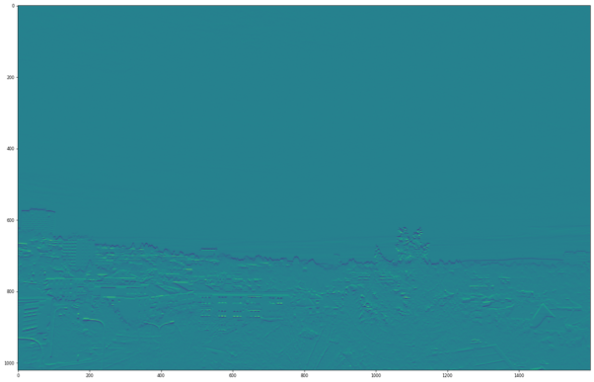

1445 Prewitt_h

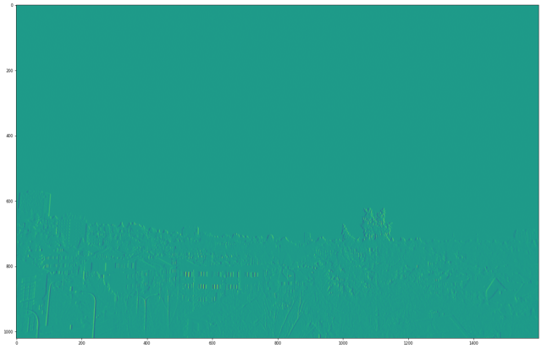

1445Prewitt_v

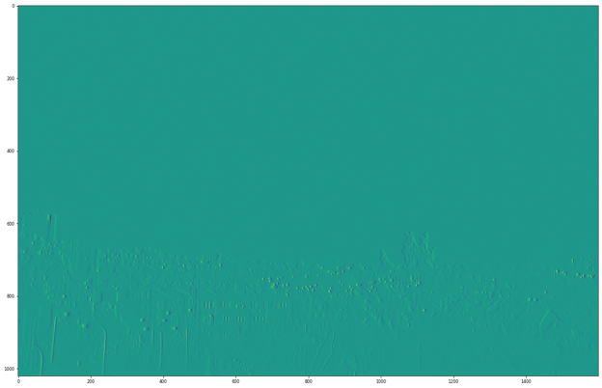

1640Prewitt_h

**Testing Colormaps**

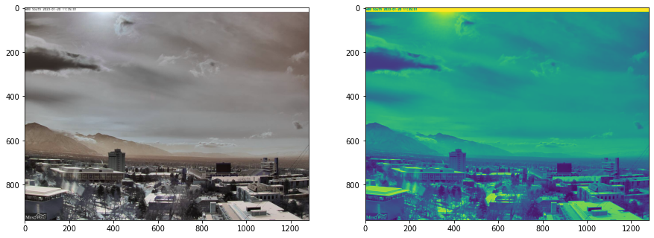

Viridis

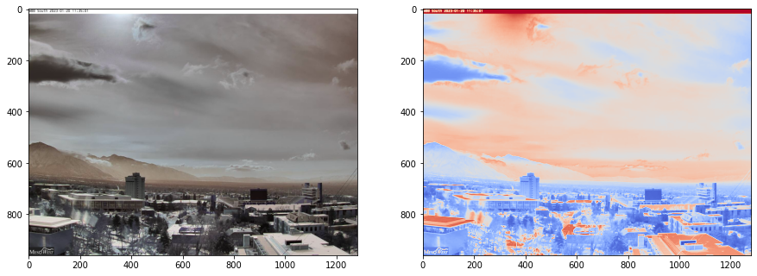

Coolwarm

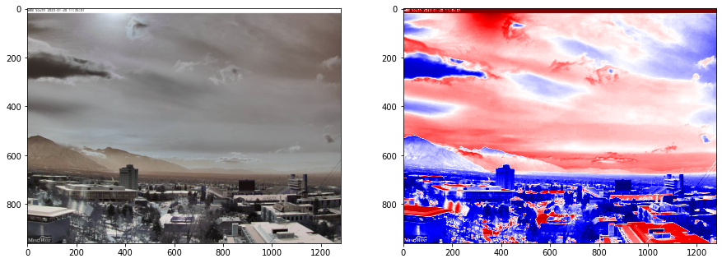

Seismic

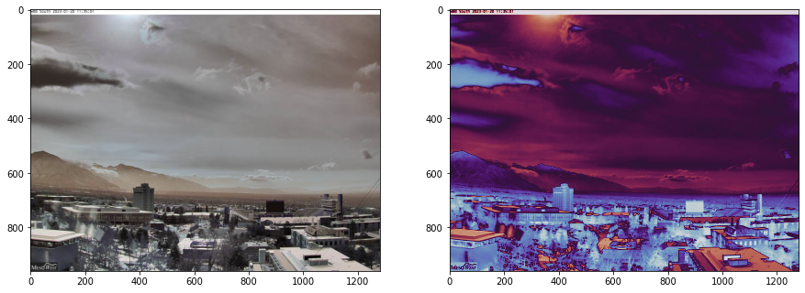

Twighlight

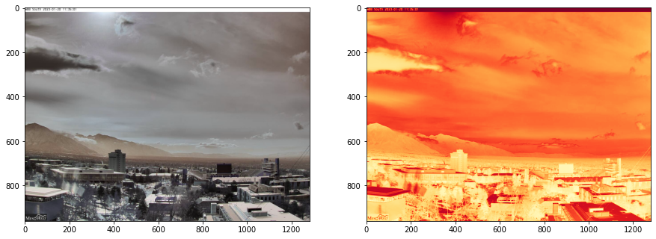

YlOrRd

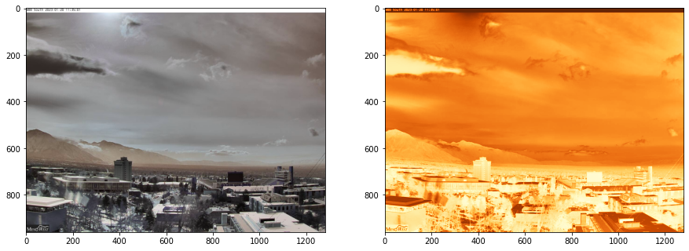

YlOrBr

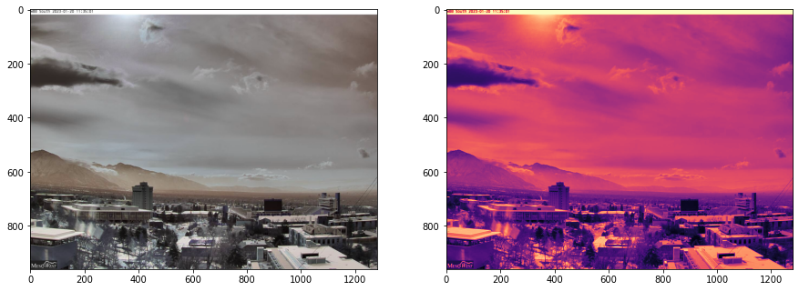

Magma

Skalky

|  |  |
| --- | --- |
|  |  |
| Day | 11:15 Cropped |
|  |  |
| Night 0400 | Night 1730 |

Kobyli

|  |  |
| --- | --- |
|  |  |
| Gamma 0.5, CAVOK, 15:20 | gamma 0.5, Dark |
|  |  |
| Scharr vertical (very similar to Prewitt) | Power line post |

**Differences and FG visualisation**

|  |  |
| --- | --- |
|  |  |
|  |  |
| Difference of very similar images (15:25 and 16:00), result and histogram | |

|  |  |
| --- | --- |
|  |  |
|  |  |
| Apply diff to building and FG – result and histogram | |

|  |  |  |
| --- | --- | --- |
|  |  |  |
| FG – Brno | FG -Skalky | BR – Brno (Building) |

Klinovec

